Design 2

Class diagram

Module register as a member
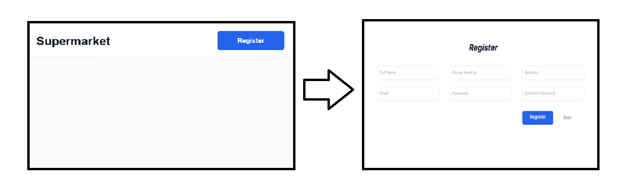
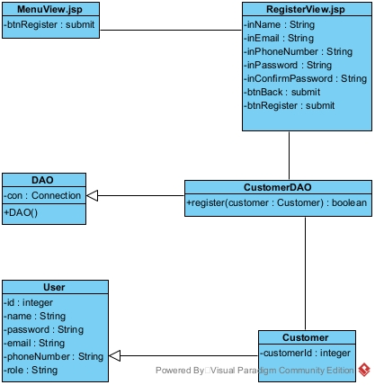

Module view customer statistics by revenue
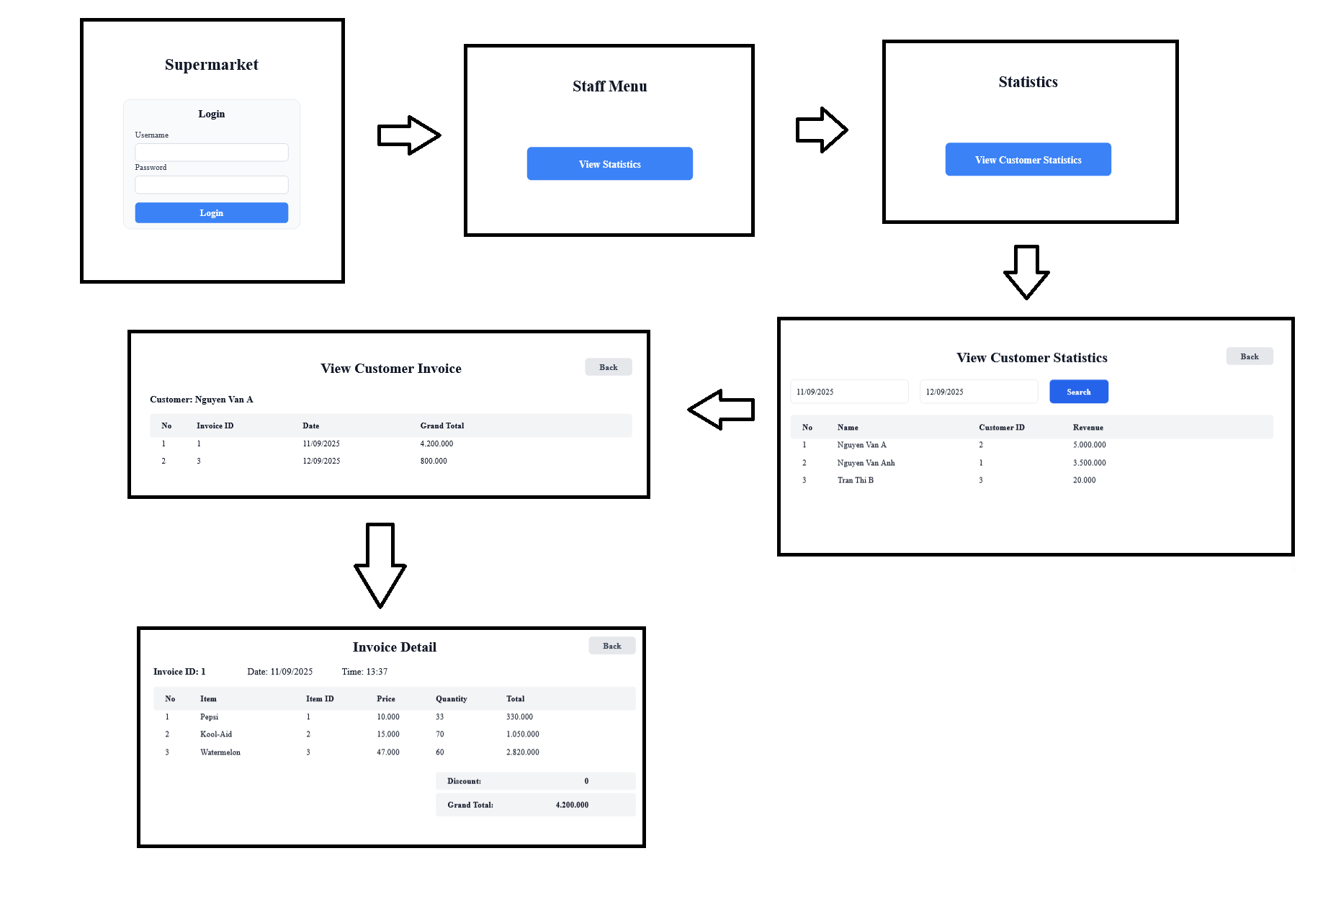
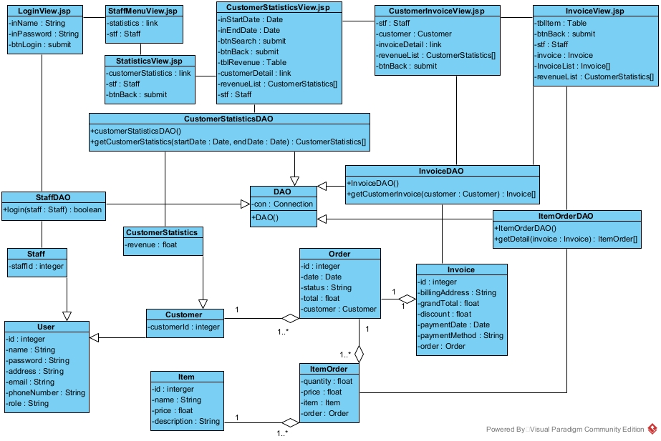

Activity diagram

Module register as a member
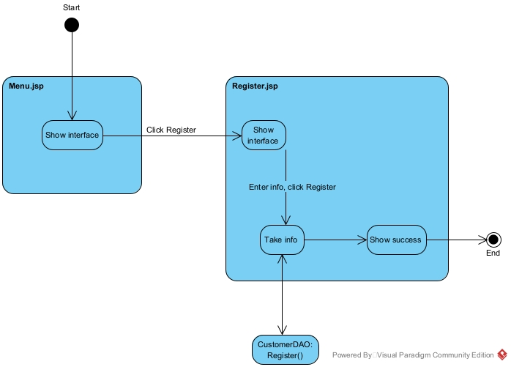

Module view customer statistics by revenue

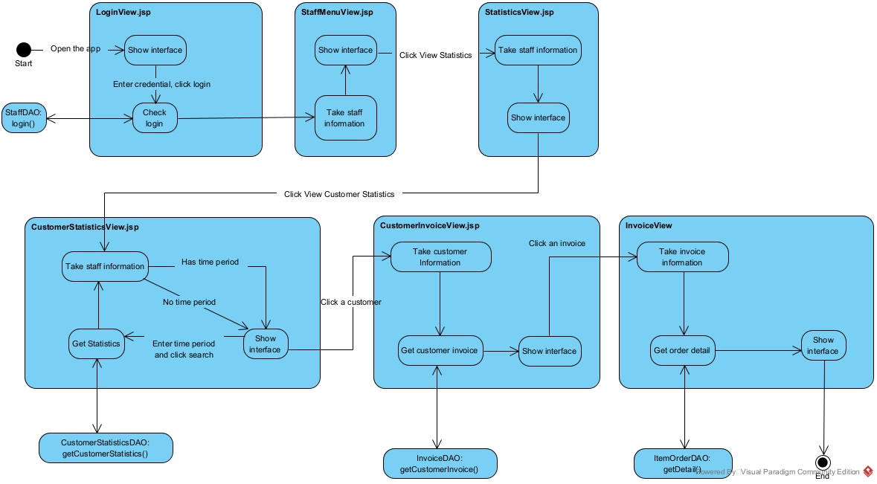

Scenario 3.0

Module register as customer
- In main menu interface, customer click register
- The interface MenuView.jsp call the interface RegisterView.jsp
- The interface RegisterView.jsp display itself to the customer
- The customer input information and click register
- The interface RegisterView.jsp call the class Customer
- The class Customer pack the information to a Customer object
- The class Customer return the Customer object to interface RegisterView.jsp
- The interface RegisterView.jsp call the class CustomerDAO
- The class CustomerDAO execute register()
- The class CustomerDAO return the result to the interface RegisterView.jsp
- Class RegisterView.jsp display success message

Module view customer statistics by revenue
- In the login interface, management staff enter username, password and click Login
- The interface LoginView.jsp call the class Staff
- The class Staff pack the information into a Staff object
- The class Staff return the object to the interface LoginView.jsp
- The interface LoginView.jsp call the class StaffDAO
- The class StaffDAO execute login()
- The class StaffDAO return the result to the interface LoginView.jsp
- The interface LoginView.jsp call the interface StaffMenuView.jsp
- The interface StaffMenuView.jsp display to the management staff
- In staff menu interface, management staff click view statistics
- The interface StaffMenuView.jsp call the interface StatisticsView.jsp
- The interface StatisticsView.jsp display to the management staff
- The staff click view customer statistics by revenue
- The interface StatisticsView.jsp call the interface CustomerStatisticsView.jsp
- The interface CustomerStatisticsView.jsp display to the management staff
- The staff enter date and click search
- The interface CustomerStatisticsView.jsp call the class CustomerStatisticsDAO
- The class CustomerStatisticsDAO execute getCustomerStatistics()
- The class CustomerStatisticsDAO call the class CustomerStatistics
- The class CustomerStatistics pack the information into a CustomerStatistics object
- The class CustomerStatistics return the object to the class CustomerStatisticsDAO
- The class CustomerStatisticsDAO return the result to the interface CustomerStatisticsView.jsp
- The interface CustomerStatisticsView.jsp display the result to the management staff
- The management staff click a customer
- The interface CustomerStatisticsView.jsp call the interface CustomerInvoiceView.jsp
- The interface CustomerInvoiceView.jsp call the class InvoiceDAO
- The class InvoiceDAO execute getCustomerInvoice()
- The class InvoiceDAO call the class Invoice
- The class Invoice pack the information into an Invoice object
- The class Invoice return the result to the class InvoiceDAO
- The class InvoiceDAO return the result to the interface CustomerInvoiceView.jsp
- The interface CustomerInvoiceView.jsp display the result
- The management staff click an invoice
- The interface CustomerInvoiceView.jsp call the interface InvoiceView.jsp
- The interface InvoiceView.jsp call the class ItemOrder
- The class ItemOrder execute the function getOrderDetail()
- The class ItemOrder call the class Item
- The class Item pack the information into an Item object
- The class Item return the object to the class ItemOrderDAO
- The class ItemOrderDAO call the class ItemOrder
- The class ItemOrder pack the information into an ItemOrder object
- The class ItemOrder return the result to the class ItemOrderDAO
- The class ItemOrderDAO return the result to the interface InvoiceView.jsp
- The interface InvoiceView.jsp display the result to the management staff

Sequence diagram

Module register as a member
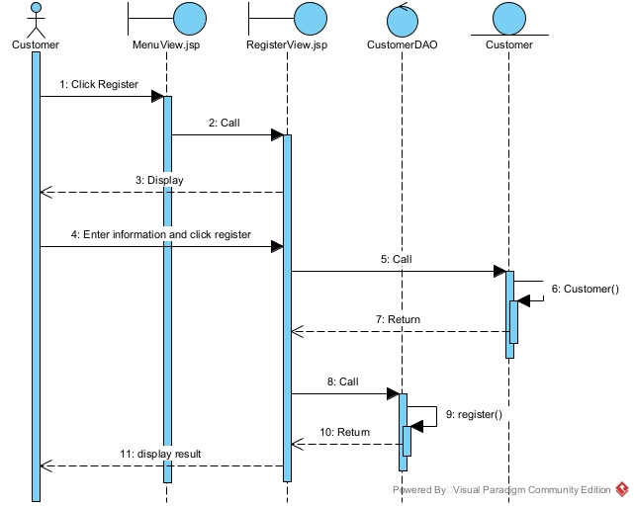

Module view customer statistics by revenue
